CHRISTMAS

GREETING

2018

  - This year, I went on a “part mission, part visitation of families and friends, and part Japan 4 major cities traveling via bullet train

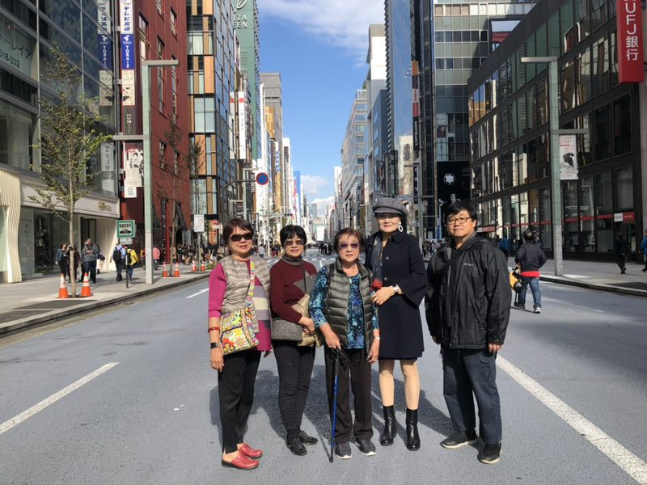
Visitation of elementary and good friends in Tokyo, Japan. This is a photo of us on the street of Ginza, Japan.
“A friend loves at all times, and a brother is born for adversity.” Proverbs 17:17
This trip really brought fond memories for my friends. I also enjoyed serving at Goya Baptist Church on Okinawa. The fellowship ladies there are very loving and gave me such encouragement to go back again to teach them stories of the Bible.
The Japan bullet train was a thrill for all of us. We went through Miyazaki, Hiroshima, Kyoto, and Tokyo. We all raved on how clean all the Japanese cities are. We hope and pray that we can do this wonderful trip again visiting other well-known Japanese cities when we hold an Okinawa Church’s Youths Reunion in 2020. May you all have a blessed and wonderful Christmas!

